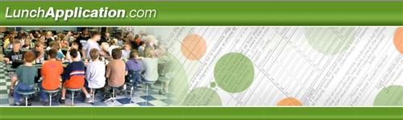

Available 7/30/18!!

Online Free and Reduced Meal Applications for:

Discovery Academy of Lake Alfred (DALA) and Discovery High School (DHS)*

*Important – If you are interested in applying for free or reduced meals, YOU MUST COMPLETE AN APPLICATION FOR DALA/DHS EVEN IF YOU HAVE COMPLETED AN APPLICATION FOR ANOTHER CHILD IN A DIFFERENT SCHOOL. If you have more than one child attending DALA and/or DHS only ONE application needs to be submitted.

If you recently received a “Direct Certification” letter from DALA/DHS then you DO NOT NEED TO APPLY. YOUR CHILD WILL RECEIVE FREE MEALS AT DALA/DHS AS INDICATED ON THE DIRECT CERTIFICATION LETTER.

Now you can apply online for your children to receive free or reduced price school meals. Your application will be sent from a secure web site directly to Discovery Academy of Lake Alfred/Discovery High School so you don’t need to worry about filling out a paper form that could be lost or misplaced.

www.LunchApplication.com has been designed to make it easier for you to know exactly what information you need to provide and to guide you through the process. Once your application has been received, your eligibility will be determined and a letter sent to you with the results.

www.LunchApplication.com is an easy, secure and convenient way to apply for free or reduced meals.

To apply, simply go to www.LunchApplication.com and Click Apply Now.

If you have any questions or concerns don’t hesitate to call Discovery Academy of Lake Alfred and ask for Mary Pulse at 863-295-5955.

