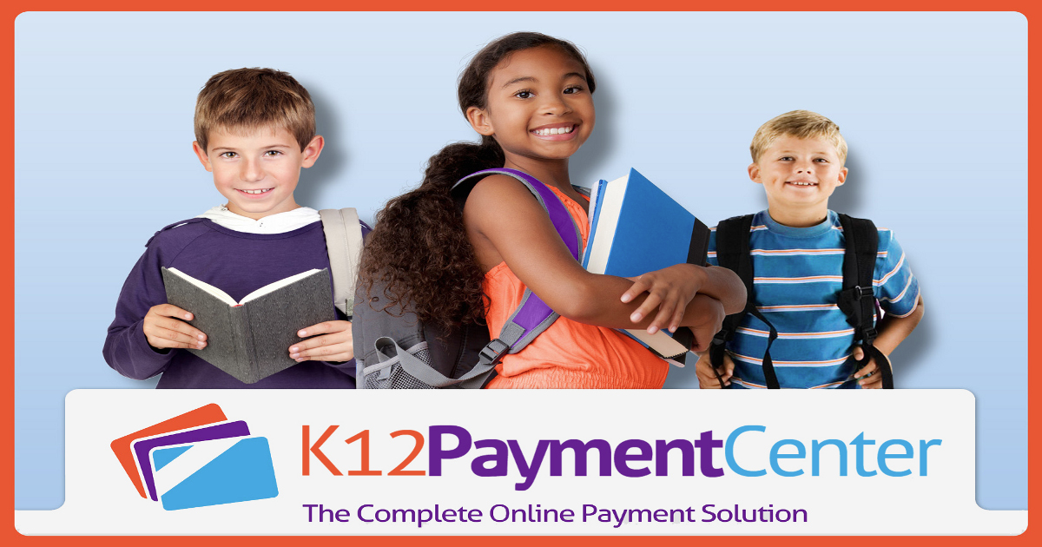

Dear Parent,

We have upgraded our online meal payment service. This year we are once again using K12PaymentCenter. You will be able to register and begin using the service 7/30/18. Dealing with your child’s lunch money just got a lot easier! You can now add money to their meal accounts online securely and even see what they are buying.

Beginning 7/30/18 go to www.K12PaymentCenter.com and click “Register Now” to create an account. Select Discovery Academy/DHS from the drop down list, fill in your information, and input your credit or debit card information and you’re ready to go! Please note that there is a $1.95 per transaction fee. You do not need to pay just to view your child’s purchases. To register, you will need your child’s student ID number; simply contact Mary Pulse, 863-295-5955 for that or any other questions you may have about our meal program.

Online Payment Website Facts:

- You can make payments for meals securely, the website utilizes all of the current industry privacy standards.
- You can deposit $ into more than one meal account at a time if you have other children at DALA/DHS, and only pay one transaction fee.
- You get quick and easy access to your child’s account 24 hours a day, 7 days a week
- You have the ability to see 120 calendar days of purchases and payments
- You can set up low balance alerts
- You can set up monthly or recurring payments
- You can access online payments in Facebook
- There are no banners or pop up ads
- None of your information is shared

For more information and a video on how to start managing your child’s meal account go to www.K12PaymentCenter.com or call Mary Pulse at 863-295-5955.

